**Data Visualization  
  
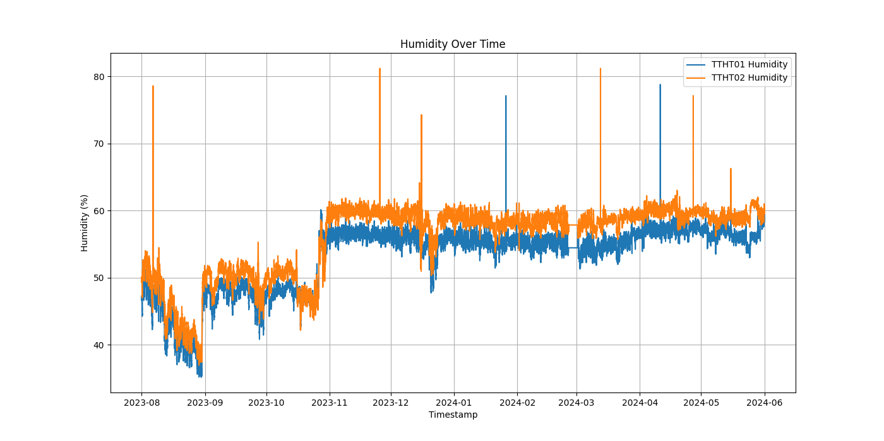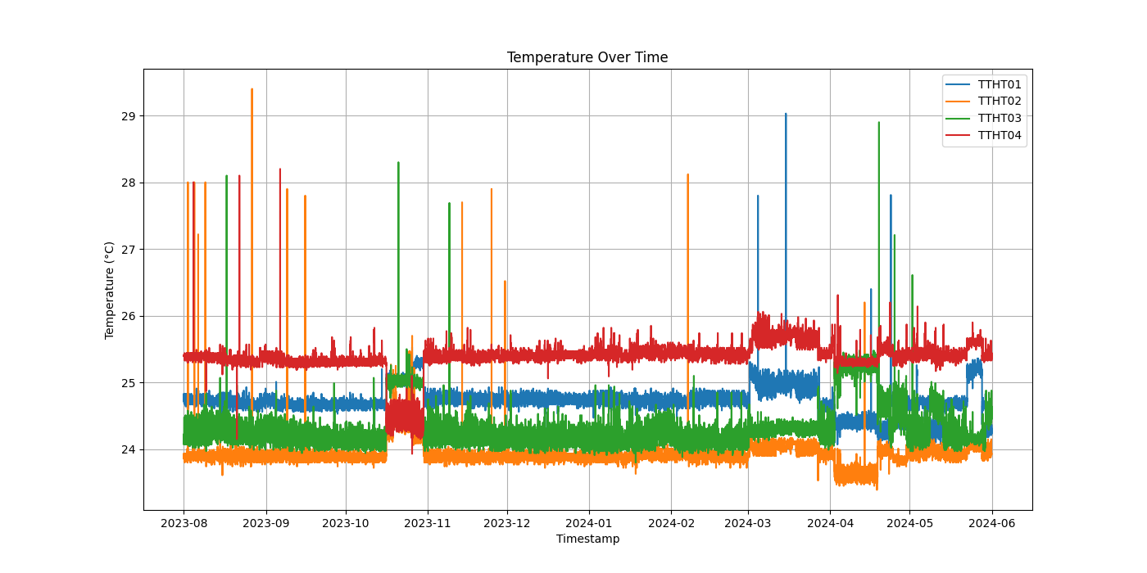**

**On Page Data Visualization**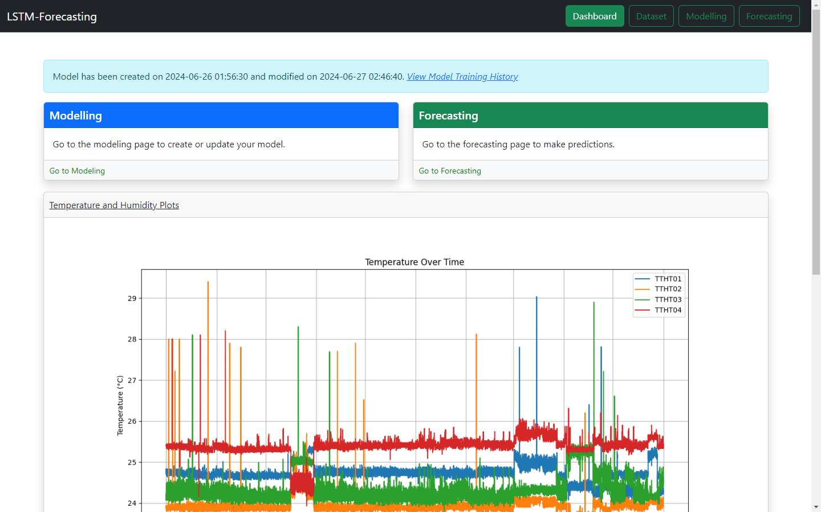

**Trial And Testing ( Input Epoch 10)**

|  |  |  |  |  |  |  |  |  |  |
| --- | --- | --- | --- | --- | --- | --- | --- | --- | --- |
| **No** | **Optimizer** | **Stopped Epoch** | **Batch Size** | **TRAINING** | | **TESTING/VALIDATION** | | | |
| **Avrg Accuracy** | **Avrg Loss** | **Accuracy** | **Loss** | **MSE** | **RMSE** |
| **1** | **ADAM** | **10** | **32** | **0.948** | **0.00035** | **0.947** | **0.00067** | **0.00035** | **0.0187** |
| **2** | **SGD** | **10** | **32** | **0.807** | **0.0022** | **0.817** | **0.00275** | **0.0022** | **0.0471** |
| **3** | **RMSprop** | **10** | **32** | **0.927** | **0.00046** | **0.780** | **0.00181** | **0.00046** | **0.0215** |

**UJI COBA 1**

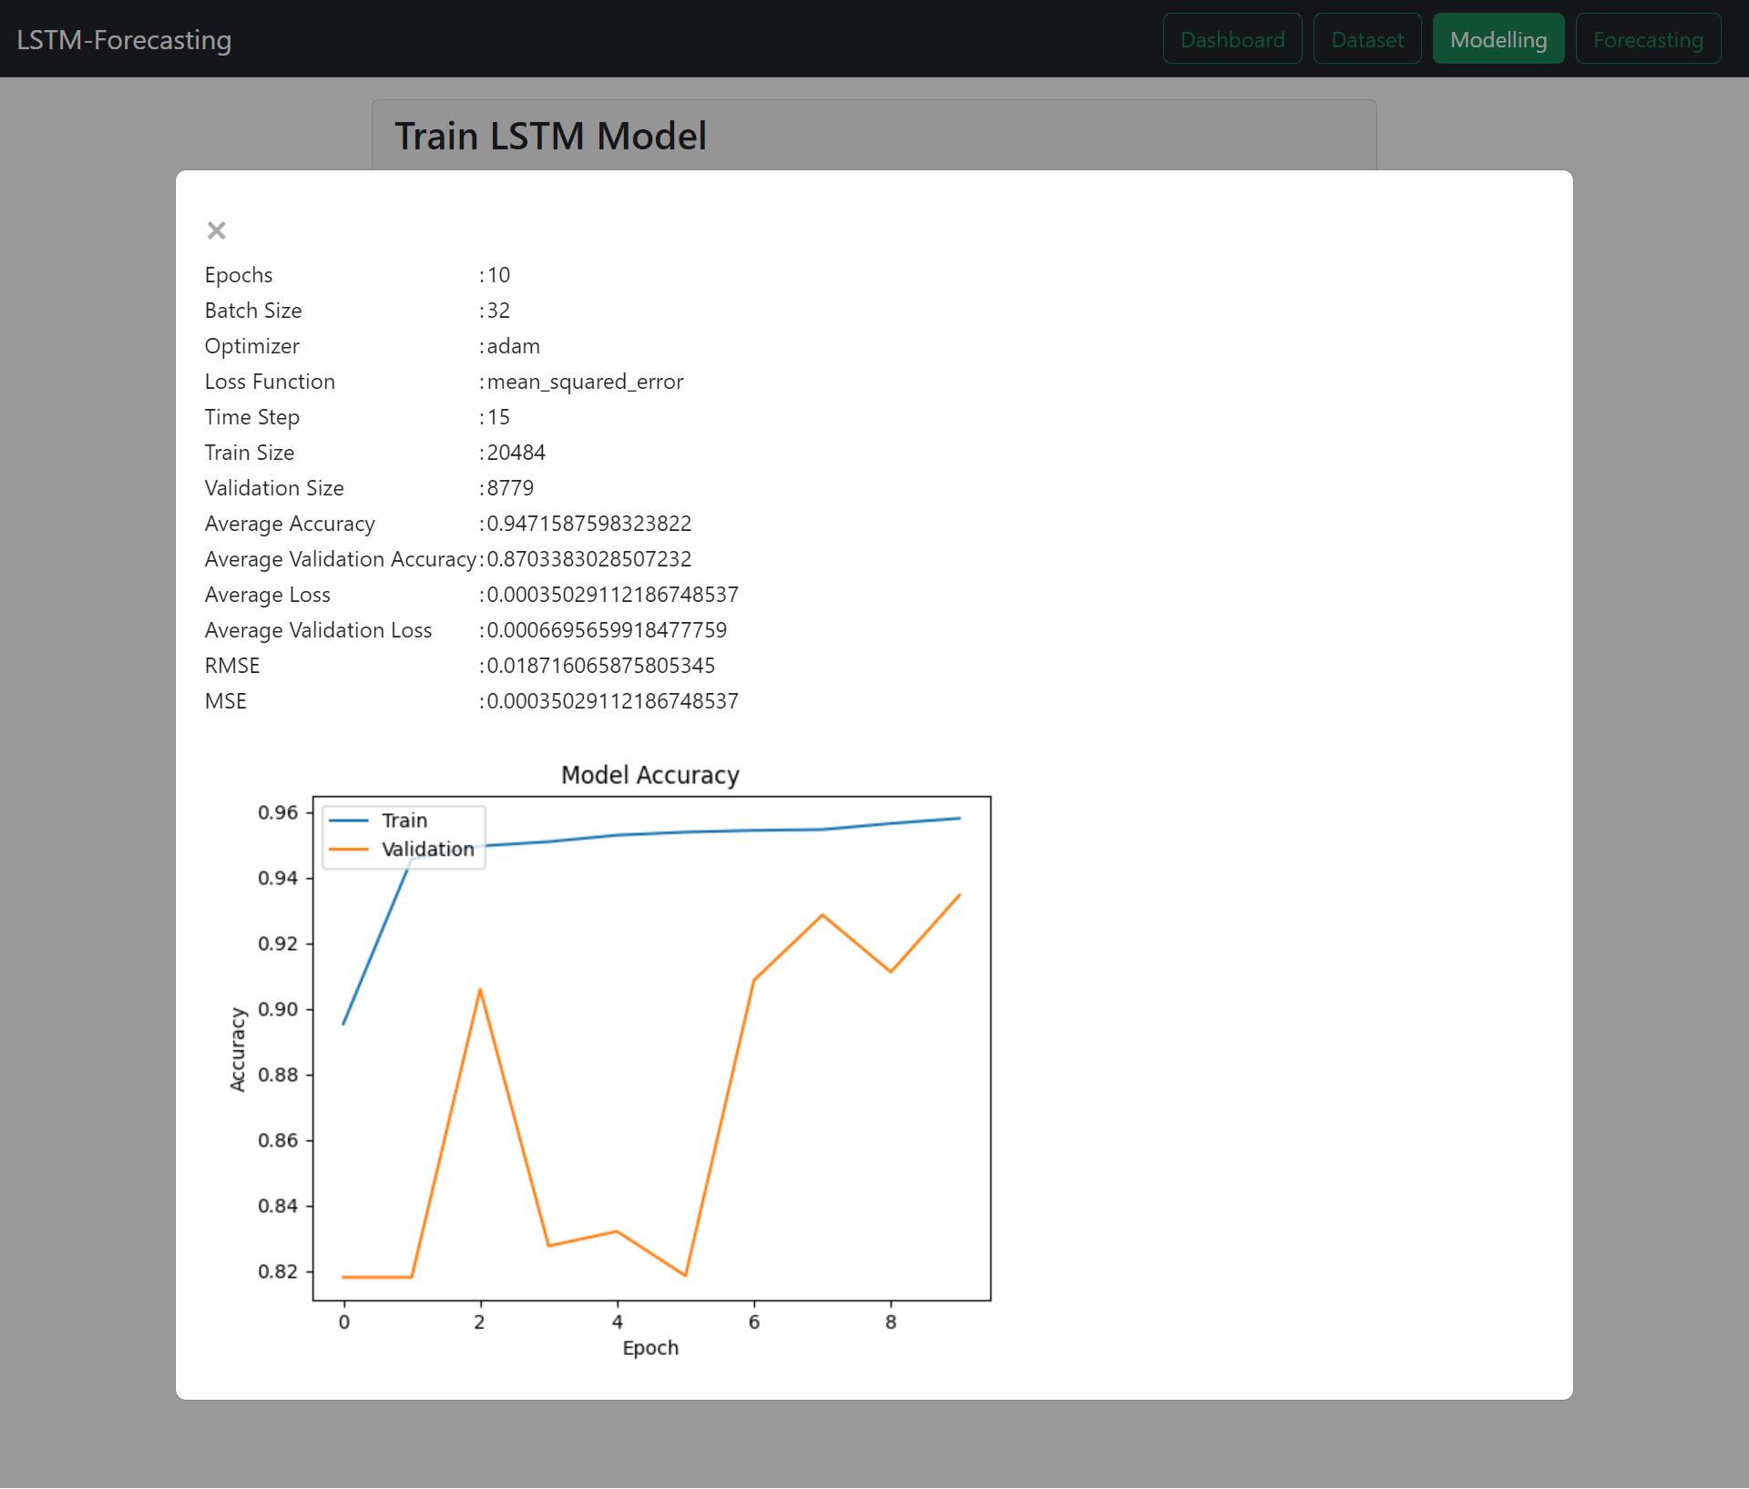

**UJI COBA 2**

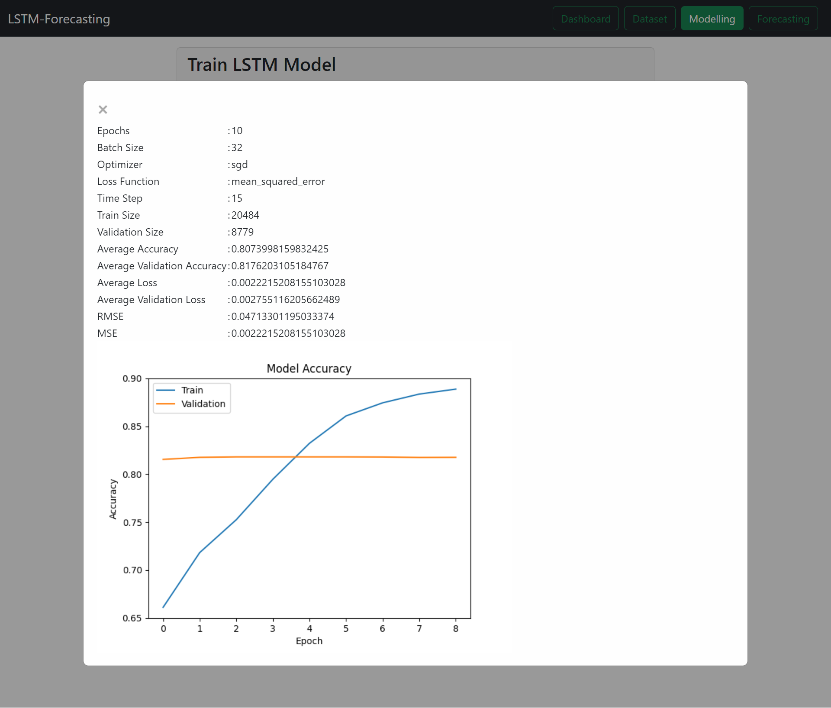

**UJI COBA 3**

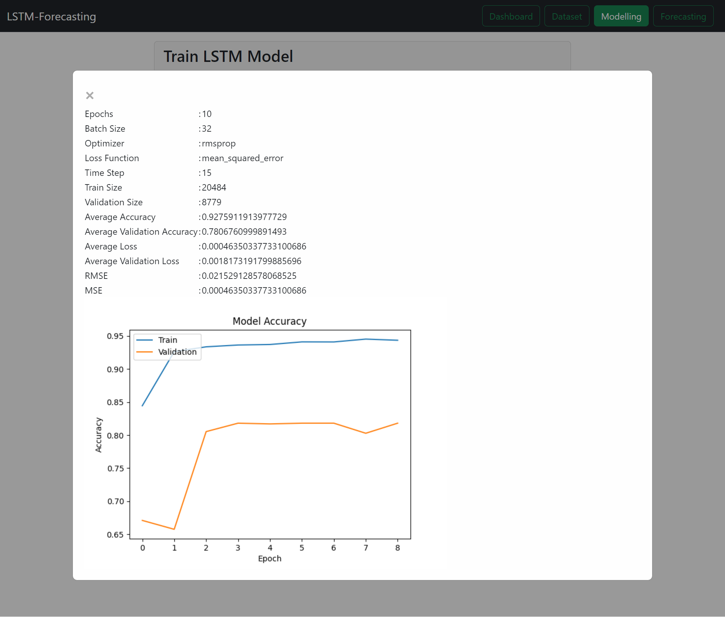

**Trial And Testing ( Input Epoch 50)**

|  |  |  |  |  |  |  |  |  |  |
| --- | --- | --- | --- | --- | --- | --- | --- | --- | --- |
| **No** | **Optimizer** | **Stopped Epoch** | **Batch Size** | **TRAINING** | | **TESTING/VALIDATION** | | | |
| **Avrg Accuracy** | **Avrg Loss** | **Accuracy** | **Loss** | **MSE** | **RMSE** |
| **1** | **ADAM** | **12** | **32** | **0,9498** | **0,0003** | **0,861** | **0,0007** | **0,0003** | **0,0180** |
| **2** | **SGD** | **28** | **32** | **0,7874** | **0,0013** | **0,555** | **0,0025** | **0,0013** | **0,0368** |
| **3** | **RMSprop** | **11** | **32** | **0,9382** | **0,0004** | **0,7669** | **0,0001** | **0,0004** | **0,0206** |

**Uji 4**

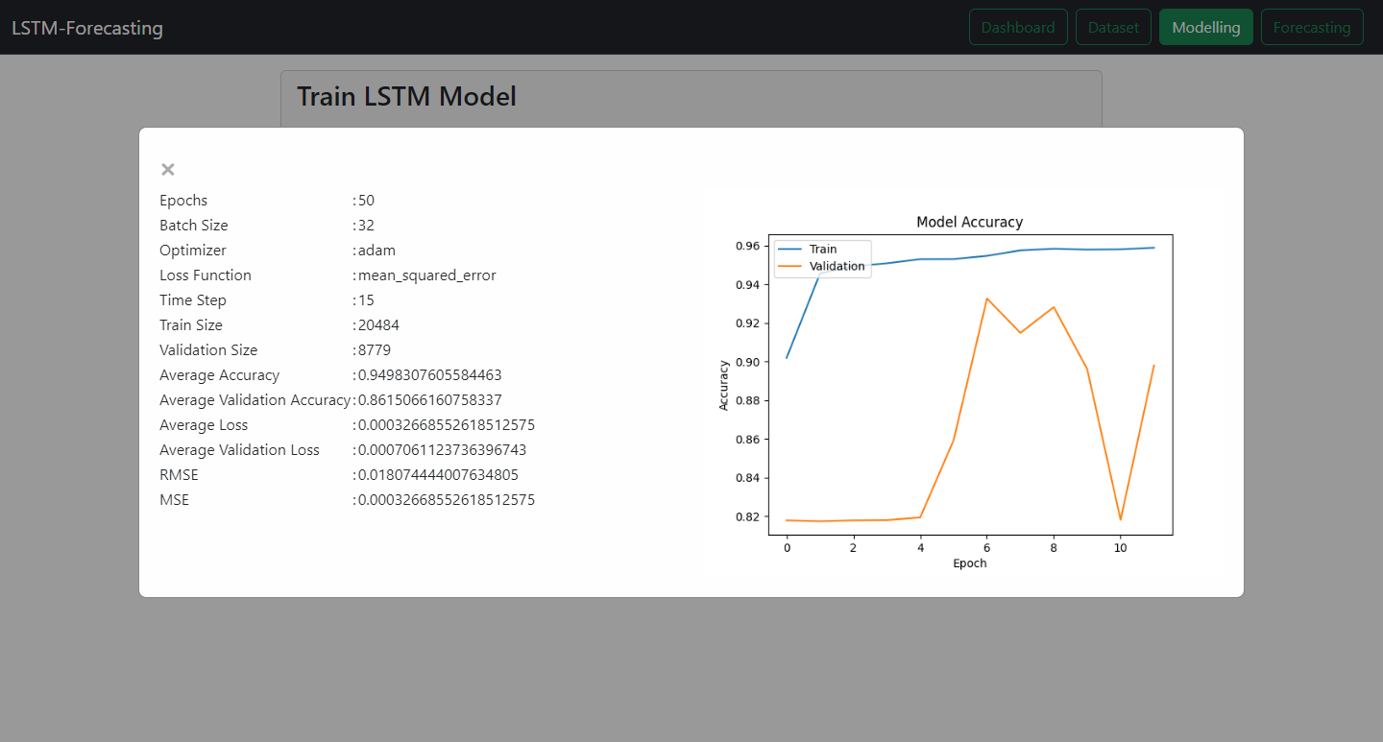

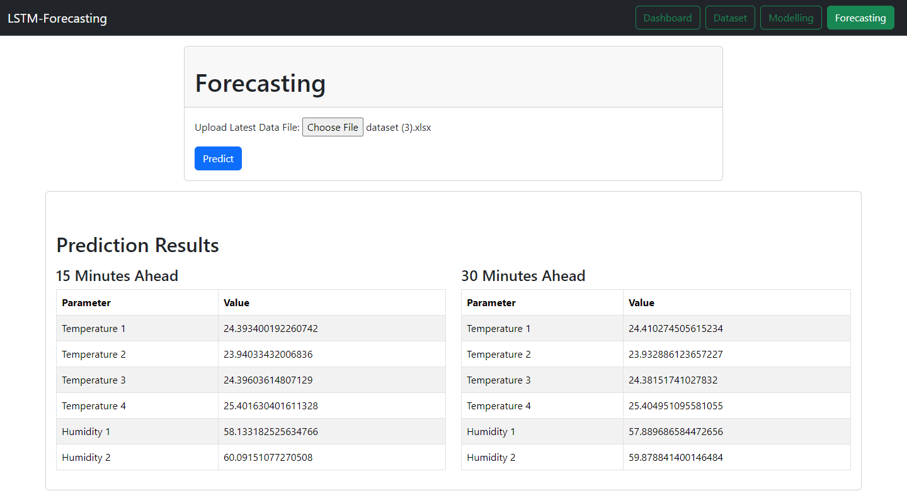

**Uji 5**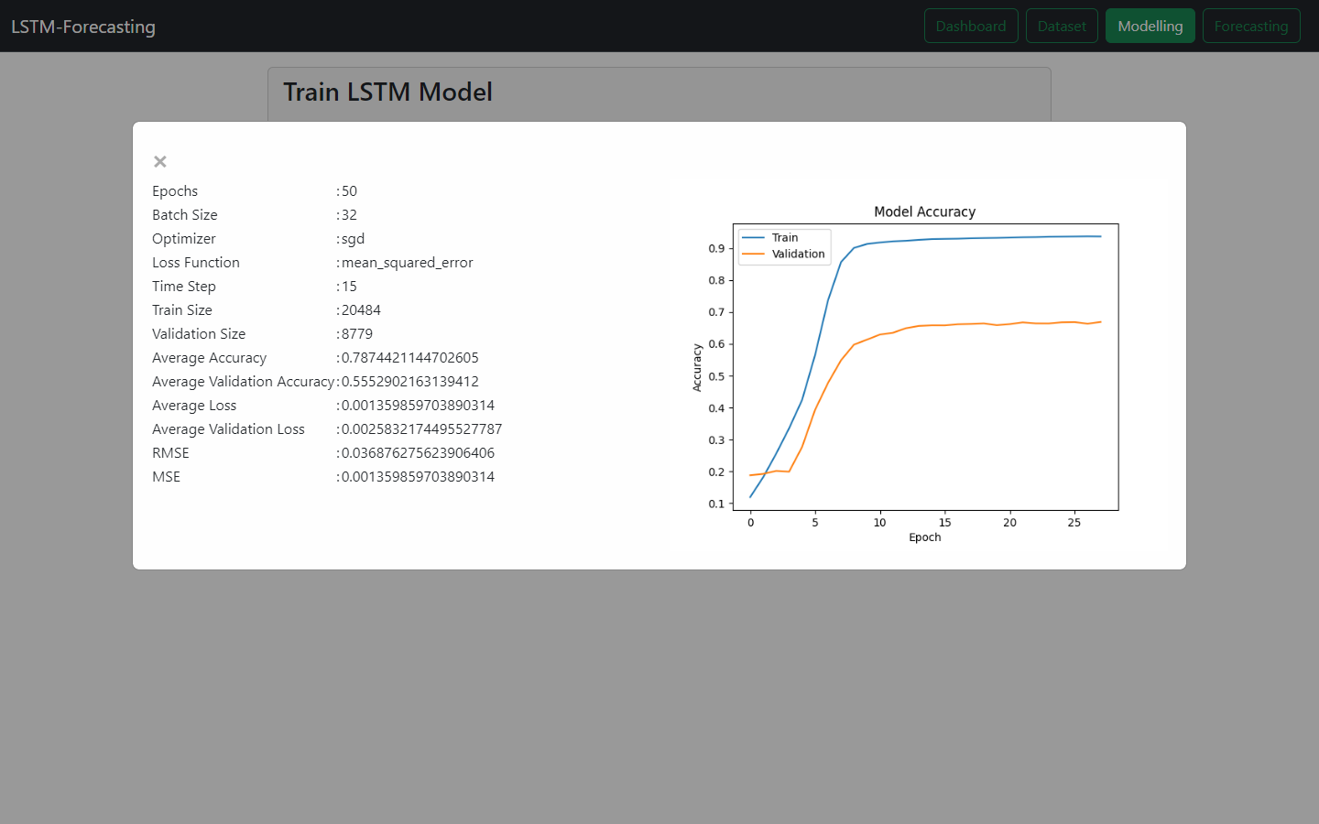

**Forcast**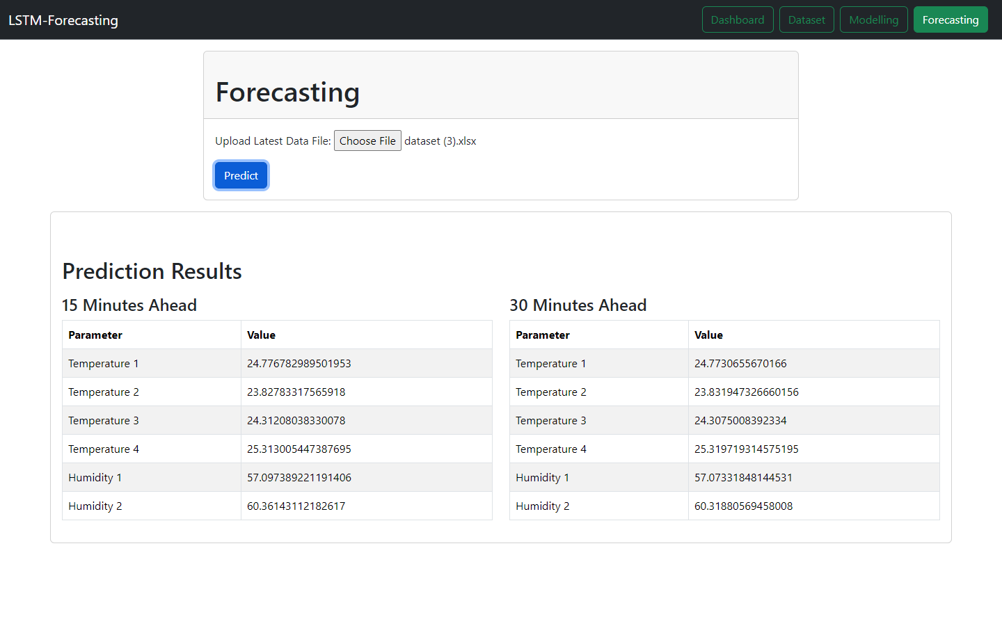

**Uji 6**

